**Assignment - 4 A Job Ready Bootcamp in C++, DSA and IOT**

Iterative Control Statements

**1. Write a program to print MySirG 5 times on the screen**

#include<stdio.h>

int main()

{

int i=0;

while(i!=5)

{

printf("MySirG\n");

i++;

}

return 0;

}

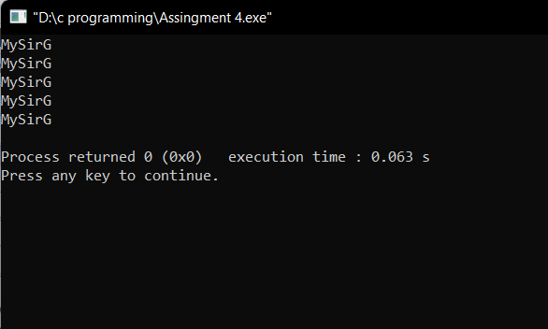

**2. Write a program to print the first 10 natural numbers.**

#include<stdio.h>

int main()

{

int i=1;

while(i!=11)

{

printf("%d\n",i);

i++;

}

return 0;

}

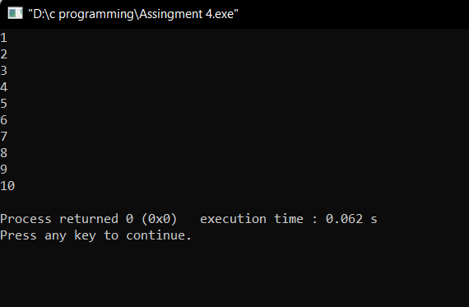

**3. Write a program to print the first 10 natural numbers in reverse order**

#include<stdio.h>

int main()

{

int i=10;

while(i!=0)

{

printf("%d\n",i);

i--;

}

return 0;

}

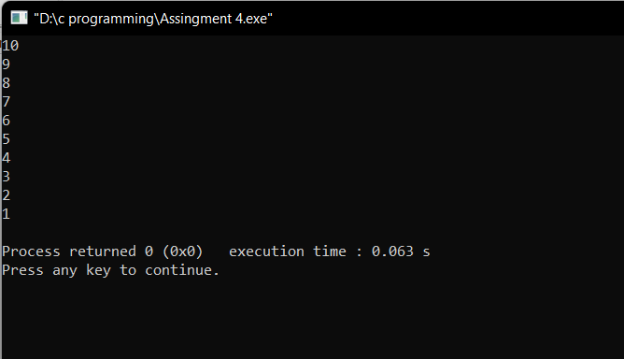

**4. Write a program to print the first 10 odd natural numbers**

#include<stdio.h>

int main()

{

int i=1;

while(i!=11)

{

printf("%d\n",i*2-1);

i++;

}

return 0;

}

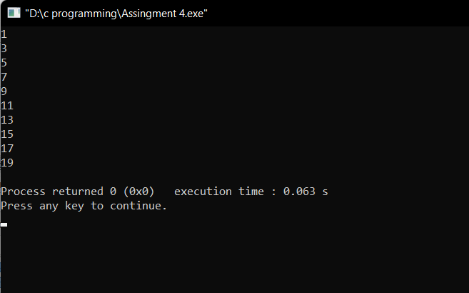

**5. Write a program to print the first 10 odd natural numbers in reverse order.**

#include<stdio.h>

int main()

{

int i=10;

while(i!=0)

{

printf("%d\n",i*2-1);

i--;

}

return 0;

}

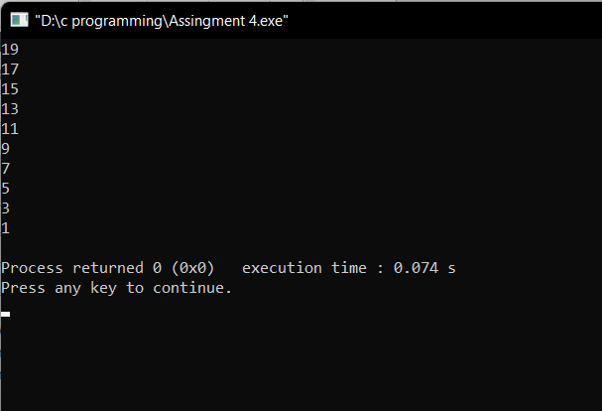

**6. Write a program to print the first 10 even natural numbers**

#include<stdio.h>

int main()

{

int i=1;

while(i!=11)

{

printf("%d\n",i*2);

i++;

}

return 0;

}

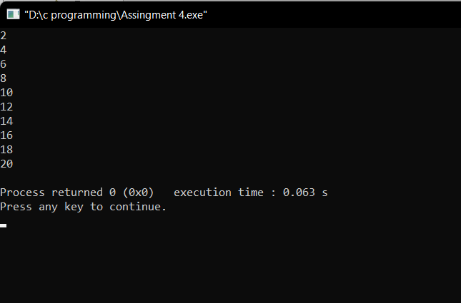

**7. Write a program to print the first 10 even natural numbers in reverse order**

#include<stdio.h>

int main()

{

int i=10;

while(i!=0)

{

printf("%d\n",i*2);

i--;

}

return 0;

}

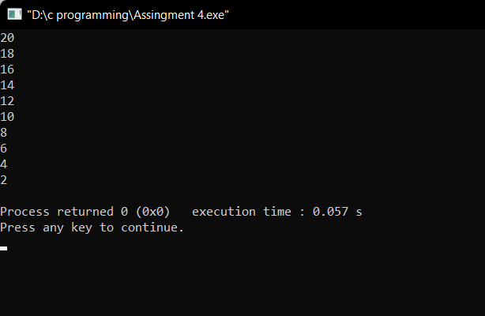

**8. Write a program to print squares of the first 10 natural numbers**

#include<stdio.h>

int main()

{

int i=1;

while(i!=11)

{

printf("%d\n",i*i);

i++;

}

return 0;

}

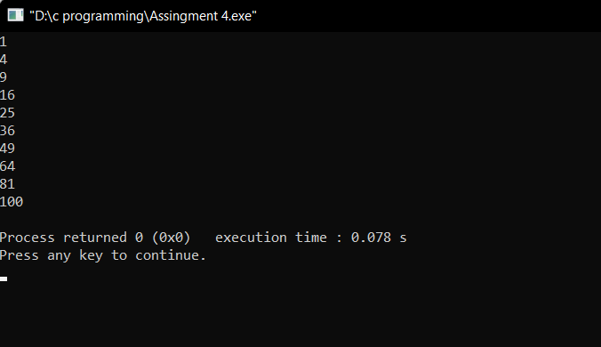

**9. Write a program to print cubes of the first 10 natural numbers**

#include<stdio.h>

int main()

{

int i=1;

while(i!=11)

{

printf("%d\n",i*i*i);

i++;

}

return 0;

}

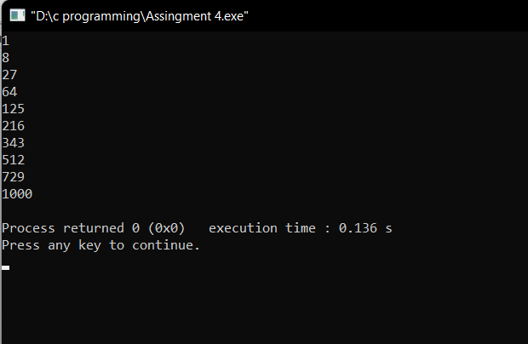

**10. Write a program to print a table of 5.**

#include<stdio.h>

int main()

{

int i=1;

while(i!=11)

{

printf("5 * %d = %d\n",i,5*i);

i++;

}

return 0;

}

